1.List 3 popular Wi-Fi standards (e.g., 802.11n, 802.11ac, 802.11ax) and for each, write one key difference in speed or frequency band.
Wi-Fi Standard | Frequency Band | One Key Difference
802.11n (Wi-Fi 4) | 2.4 GHz & 5 GHz | Supports speeds up to 600 Mbps.
802.11ac (Wi-Fi 5) | 5 GHz only | Faster than 802.11n, with speeds up to 3.5 Gbps.
802.11ax (Wi-Fi 6) | 2.4 GHz & 5 GHz (also 6 GHz with Wi-Fi 6E) | Offers higher speed (up to 9.6 Gbps) and better performance with many connected devices.

2.Draw a simple diagram (on paper or using any drawing tool) showing how your smartphone connects to the internet via a Wi-Fi router at home, labeling the wireless and wired parts of the network.
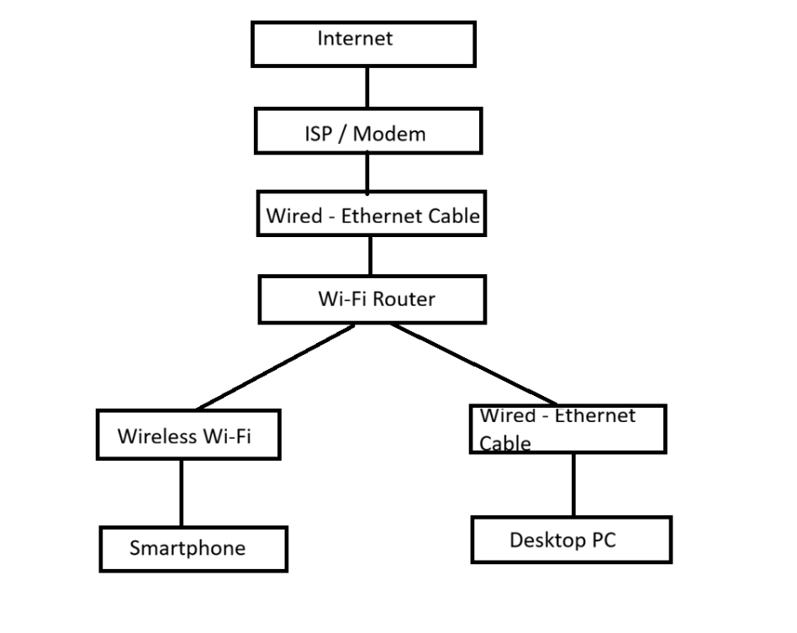
3.Scan for available Wi-Fi networks using your laptop or phone, note down the SSID, signal strength, and security type (WPA2, WPA3, etc.) for at least 3 networks, and explain which one you would choose and why.<br><br><em><strong>Hint:</strong> Consider both signal strength and security when choosing.</em>
SSID (Wi-Fi Name) | Signal Strength | Security Type
JioFiber_5G | Strong (95%) | WPA2-Personal
JioFiber_2.4G | Medium (75%) | WPA2-Personal
Airtel_Xstream | Weak (50%) | WPA3-Personal
Which network would I choose and why?
I would choose JioFiber_5G because it has the strongest signal (95%), which provides faster internet speed and a stable connection. It is also protected with WPA2 security, making it safe for everyday internet use.

4.Explain in your own words what 'SSID hiding' is in Wi-Fi networks and discuss one advantage and one disadvantage of hiding your Wi-Fi SSID.
->SSID hiding means the Wi-Fi network name (SSID) is not shown in the list of available Wi-Fi networks. Users must know the exact network name and password to connect to it.
Advantage:
Hiding the SSID makes the Wi-Fi network less visible to other people, so fewer users will try to connect to it.
Disadvantage:
It does not provide complete security because the network can still be detected using special tools. Also, users have to enter the Wi-Fi name manually to connect.
Conclusion:
SSID hiding can give a little extra privacy, but it should be used together with strong security like WPA2 or WPA3 for better protection.

